Flow Based Architecture for Multi-User Intelligent Chat System

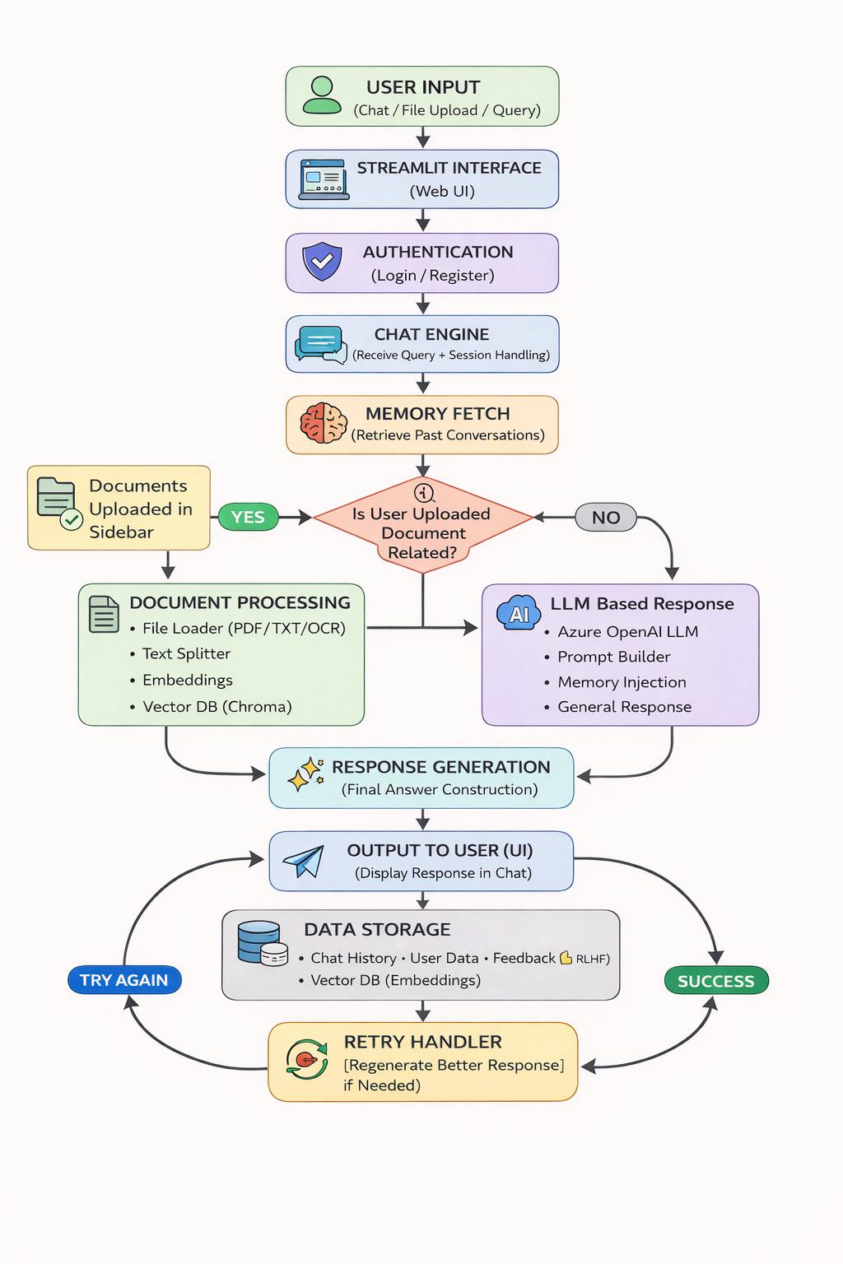

Multi-User ChatBot Application WorkFlow

User (Streamlit UI)
│
▼
Frontend (Chat UI + Upload + Auth)
│
▼
Application Layer
├── Auth Module
├── Chat Engine
├── Memory Module
└── Retry Handler
│
▼
Decision Layer
├── RAG Pipeline ──► ChromaDB (Embeddings)
└── General LLM ──► Azure OpenAI
│
▼
Response Generation
│
▼
Chat History + Feedback Storage (ChromaDB)
│
▼
UI Display (Streamlit)

Technical Design & Architecture Documentation
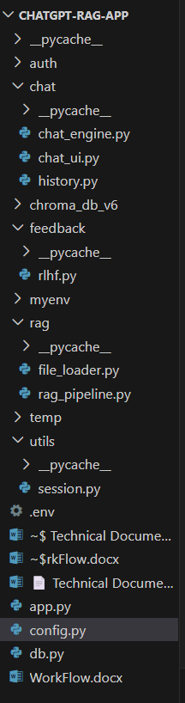

1. Core Application Files
- app.py: Your main entry point. This is the Streamlit script that runs the UI, handles user input, and coordinates the flow between the retriever and the LLM.
- config.py: Likely stores your API keys (Azure OpenAI, ChromaDB settings), environment variables, and model configurations (like llm1 and llm2).
- db.py: Contains the logic for connecting to your database, possibly handling user authentication or metadata storage.

2. The chat/ Folder (Conversation Logic)
- chat_engine.py: The "brain" that manages the logic of how the chat responds. It likely coordinates when to use the retriever versus when to use general AI knowledge.
- chat_ui.py: Contains modular Streamlit components for the chat interface, such as the st.chat_message loops and the feedback buttons.
- history.py: Manages the persistent session history. It likely contains the get_history() function we saw in your code to pull past interactions from ChromaDB or a SQL database.

3. The rag/ Folder (The Engine Room)
- file_loader.py: Handles the heavy lifting of reading the PDFs, Word docs (like WorkFlow.docx), and images you upload. It probably uses PyPDF2 or python-docx to extract text.
- rag_pipeline.py: This is where the LangChain magic happens. It likely contains the logic for splitting text into chunks, generating embeddings, and storing them in your vector store.

4. Supporting Modules
- feedback/rlhf.py: Handles the "Reinforcement Learning from Human Feedback" aspect—specifically saving those "Thumbs Up/Down" interactions to improve future responses.
- utils/session.py: Manages the st.session_state variables, ensuring that user-specific data (like display_name or retry_trigger) stays consistent during a session.
- chroma_db_v6/: This is the local directory where your vector database is actually stored. It contains the indexed versions of your documents.

5. Temporary & Environment Files
- .env: A hidden file for sensitive secrets (API Keys). Never share this screenshot.
- myenv/: Your Python virtual environment containing all your installed packages like langchain, streamlit, and openai.
- temp/: Likely a staging area where uploaded files are saved before they are processed by the file_loader.py.

📄 Technical Documentation: Multi-User RAG System
1. System Architecture
The system is built using a Modular RAG Architecture. It separates the "Heavy" compute resources (LLM and Vector Embeddings) from the "Dynamic" user context (Session Identity and History).
- Frontend: Streamlit (Python-based web framework).
- Orchestration: LangChain (Chains for history-aware retrieval and document processing).
- LLM & Embeddings: Azure OpenAI (GPT-4 and Text-Embedding-Ada-002).
- Vector Database: ChromaDB (Persistent storage for PDF chunks).
- Session/User Database: ChromaDB (Separate collection for JSON-serialized chat history and user credentials).

2. Component Breakdown
A. Authentication & User Isolation
The system uses a Metadata-Filtering approach to ensure user privacy.
- Storage: User profiles and chat sessions are stored in a ChromaDB collection titled user_sessions.
- Isolation: Every database query (login or history retrieval) uses a where={"username": current_user} filter. This ensures User A can never access User B’s data.
B. The Hybrid Memory Model
The system manages memory in two distinct layers:
- Short-term (RAM): st.session_state.chat_history stores the current conversation as a list of tuples (human, ai). This is passed to LangChain on every prompt.
- Long-term (Persistent): Upon logout or every message sent, the history is serialized into a JSON string and saved to ChromaDB.
C. Dynamic Prompt Engineering
To solve the "Identity Conflict" (where one user sees another's name), the system uses Late-Binding Prompt Injection. The System Prompt is constructed after the user logs in, injecting the st.session_state.username directly into the AI's core instructions.

3. Data Flow (The Request-Response Cycle)
- Initialization: The PDF is loaded, chunked, and embedded into the vector store (cached for performance).
- User Input: The user submits a query via the Chat Input.
- Contextualization: The LLM takes the chat_history + new_query and reformulates it into a "Standalone Question" that can be understood without the previous history.
- Retrieval: The standalone question is converted to a vector and matched against the PDF chunks in ChromaDB.
- Generation: The LLM receives the PDF context, the user’s name (from the system prompt), and the chat history to generate a personalized, fact-based response.
- Persistence: The new response is appended to the database.

4. Security & Persistence
Feature | Implementation
Password Storage | Stored in ChromaDB metadata (For production, use streamlit-authenticator with hashing).
Session Persistence | UUID-based session tracking allows users to switch between multiple separate conversations.
Concurrency | Streamlit handles each user in a separate thread, but @st.cache_resource is used for shared global assets (Retriever/LLM).

5. API Configuration
The system relies on environmental variables defined in a .env file:
- AZURE_OPENAI_ENDPOINT:
- AZURE_OPENAI_API_KEY:
- AZURE_OPENAI_API_VERSION:
- AZURE_OPENAI_CHAT_DEPLOYMENT:

6. Maintenance & Scalability
- Database Growth: Periodically clear the chroma_db_storage folder if testing multiple users, or implement a "Delete All History" function as provided in the code.
- Embedding Costs: Because the PDF is cached via @st.cache_resource, the embedding cost is only incurred once per app restart, not per user.

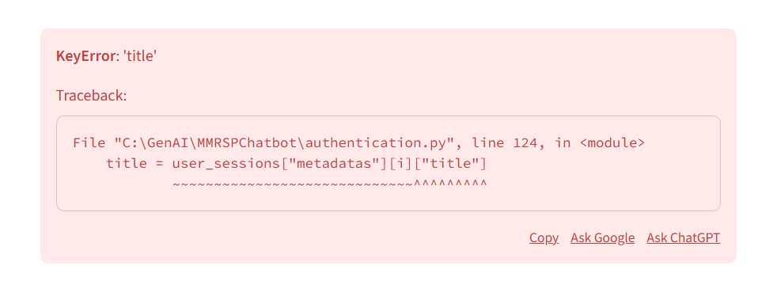
This error is a KeyError: 'title', and it’s happening because your code is trying to access a field named "title" in your database metadata that doesn't exist for at least one record.
In your code, you have two types of data in the same collection:
- User Profiles: Created during "Sign Up" (Contains password, but no title).
- Chat Sessions: Created during "Logout" or "New Chat" (Contains username and title).
When your sidebar tries to loop through everything to display chat history, it hits your "User Profile" entry, looks for a "title", doesn't find it, and crashes.

🛠️ How to Solve It
You need to tell Streamlit to only load records that are actually chat sessions (which have titles) and ignore the user profile records.
The "Safe Access" Fix (Coding Guard)
If you don't want to change the query, you can make the code "smarter" so it doesn't crash when a title is missing.
Change line 124 in your code from this:
Python
title = user_sessions["metadatas"][i]["title"]
To this:
Python
# .get() provides a fallback ("Untitled") if "title" is missing
title = user_sessions["metadatas"][i].get("title")

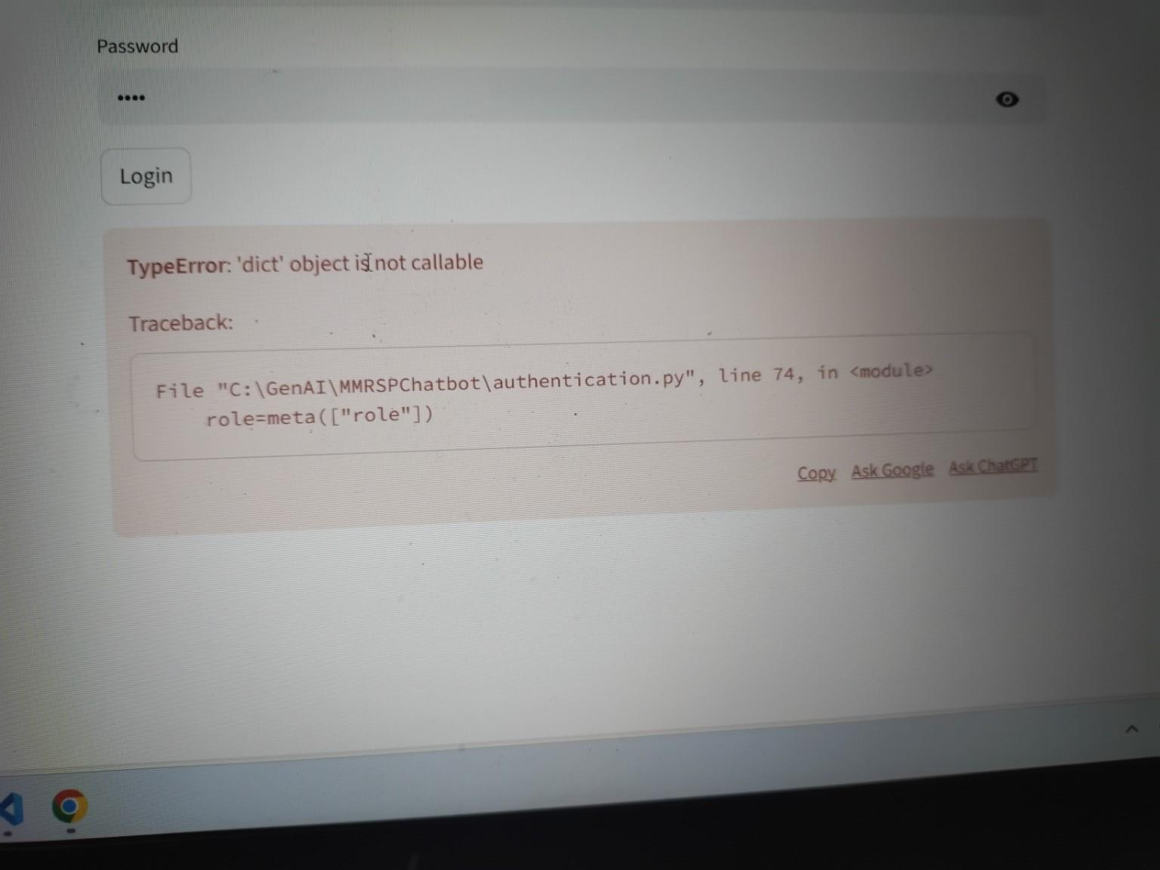

This error is a TypeError: 'dict' object is not callable.
It’s happening because you are using parentheses () instead of square brackets [] to access a value from your dictionary. In Python, () is used for calling functions, while [] is used for accessing data in a dictionary.

🔍 Why it is coming
In your code, meta is a dictionary (a dict object). When you write meta(["role"]), Python thinks you are trying to "run" or "call" meta like it's a function. Since meta is just data, Python gets confused and throws this error.

🛠️ How to solve it
Go to line 74 in your authentication.py file and change the parentheses to square brackets.
Change this:
Python
role = meta(["role"])
To this:
Python
role = meta["role"]

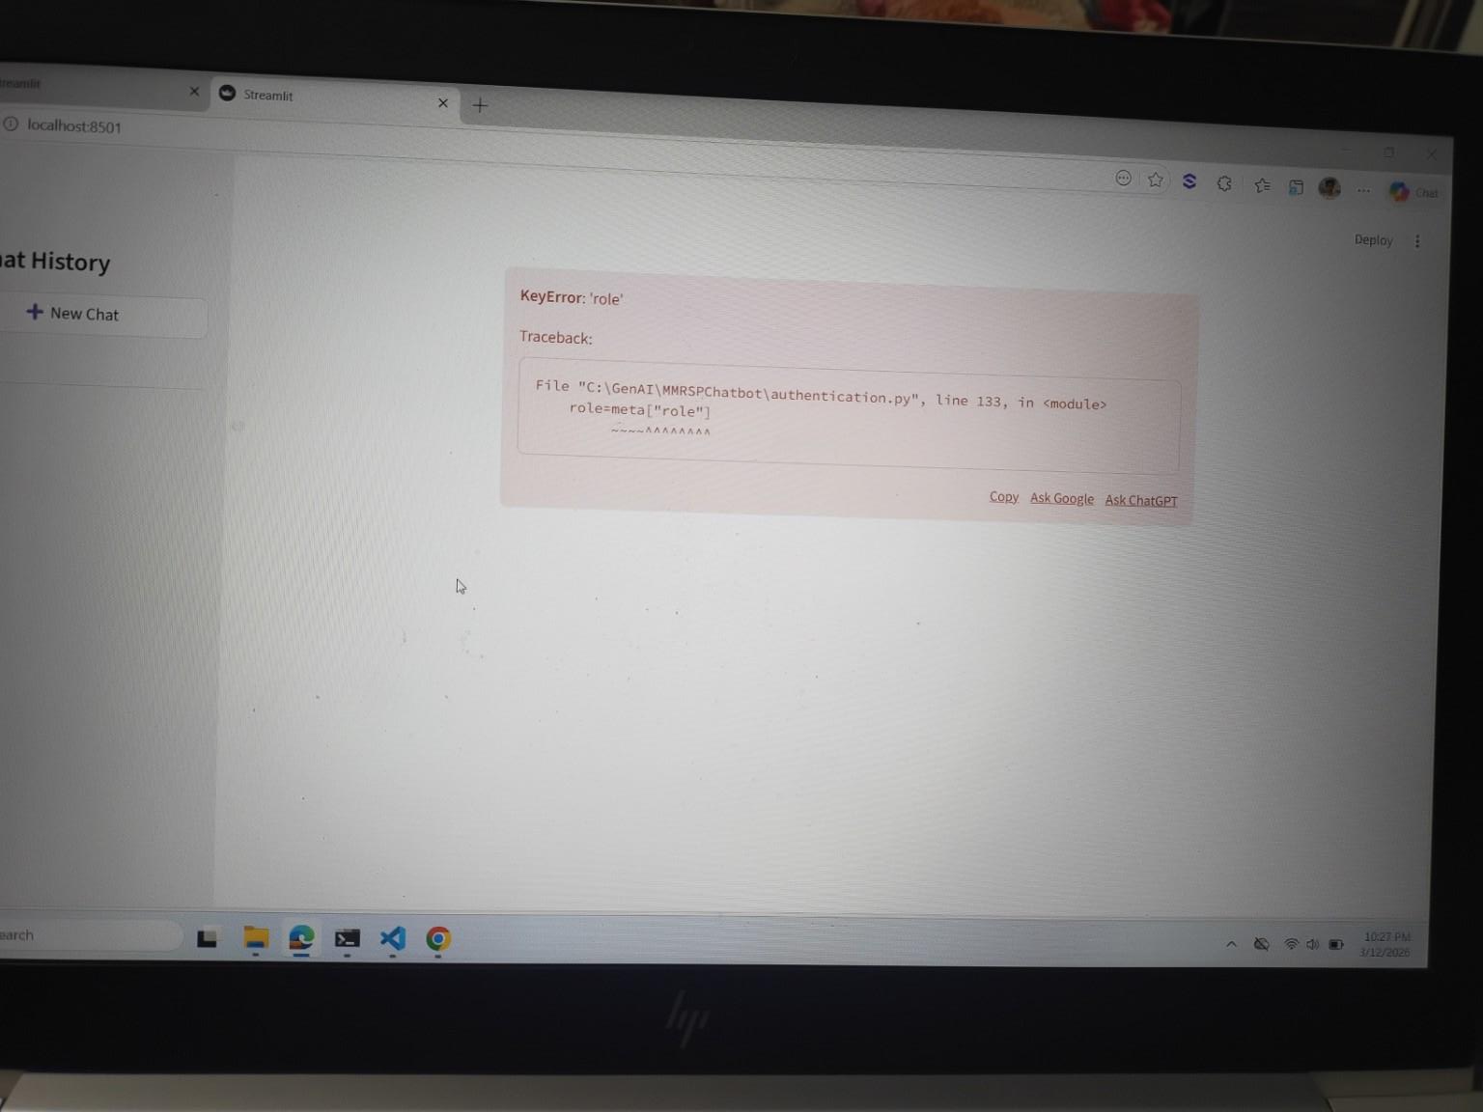
This is a KeyError: 'role'. It is very similar to the KeyError: 'title' we discussed earlier, but it is happening on line 133.
🔍 Why it is coming
A KeyError means your code is looking for a piece of data called "role" inside a dictionary (meta), but that data simply isn't there.
This is happening because your ChromaDB collection contains two different types of data:
- Chat Messages: These have a "role" (user or assistant).
- User Profiles / Session Summaries: These likely do not have a "role" field.
When your code loops through all your saved data to rebuild the chat history, it eventually hits a record that doesn't have a role, and the whole app crashes.

🛠️ How to solve it
You need to use a "Safe Access" method. Instead of forcing the code to find "role", tell it to use a default value if it can't find it.
Change line 133 from this:
Python
role = meta["role"]
To this:
Python
# Using .get() prevents the crash.
# It looks for "role", but if it's missing, it just uses "user" as a backup.
role = meta.get("role", "user")
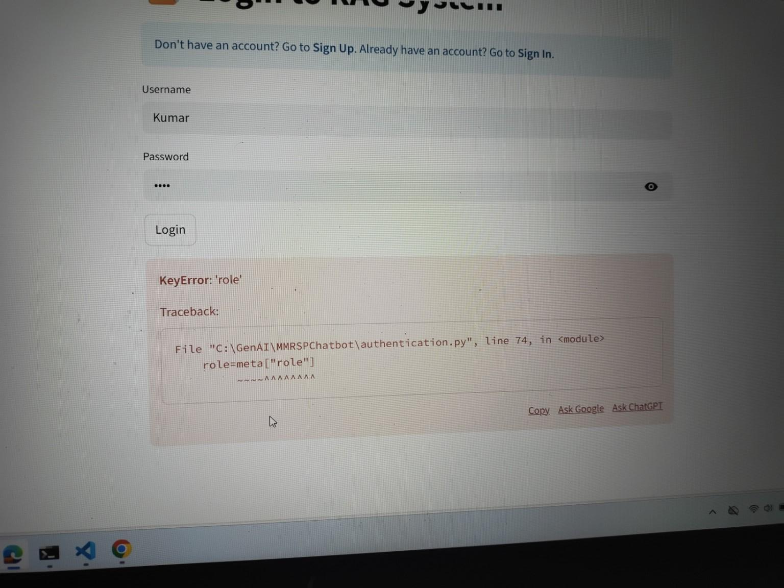

This is another KeyError: 'role', but this time it is happening right at the Login (Sign In) stage on line 74.

🔍 Why it is coming
This error is happening because your code is trying to load all records from your ChromaDB collection when a user logs in, but it's getting confused between "User Profile" data and "Chat Message" data.
- When you Sign Up, you save a record with just a password. It has no "role".
- Your code on line 74 is looping through the database and expects every single item to have a "role" (like "user" or "assistant").
- When it hits the record for the username "Kumar" (the profile you just created), it looks for "role", doesn't find it, and crashes.

🛠️ How to solve it
You need to make the data access "safe" so that if the record is a User Profile (which has no role), the code doesn't break.
Change line 74 from this:
Python
role = meta["role"]
To this:
Python
# Using .get() allows the code to continue even if "role" is missing.
role = meta.get("role", "user")
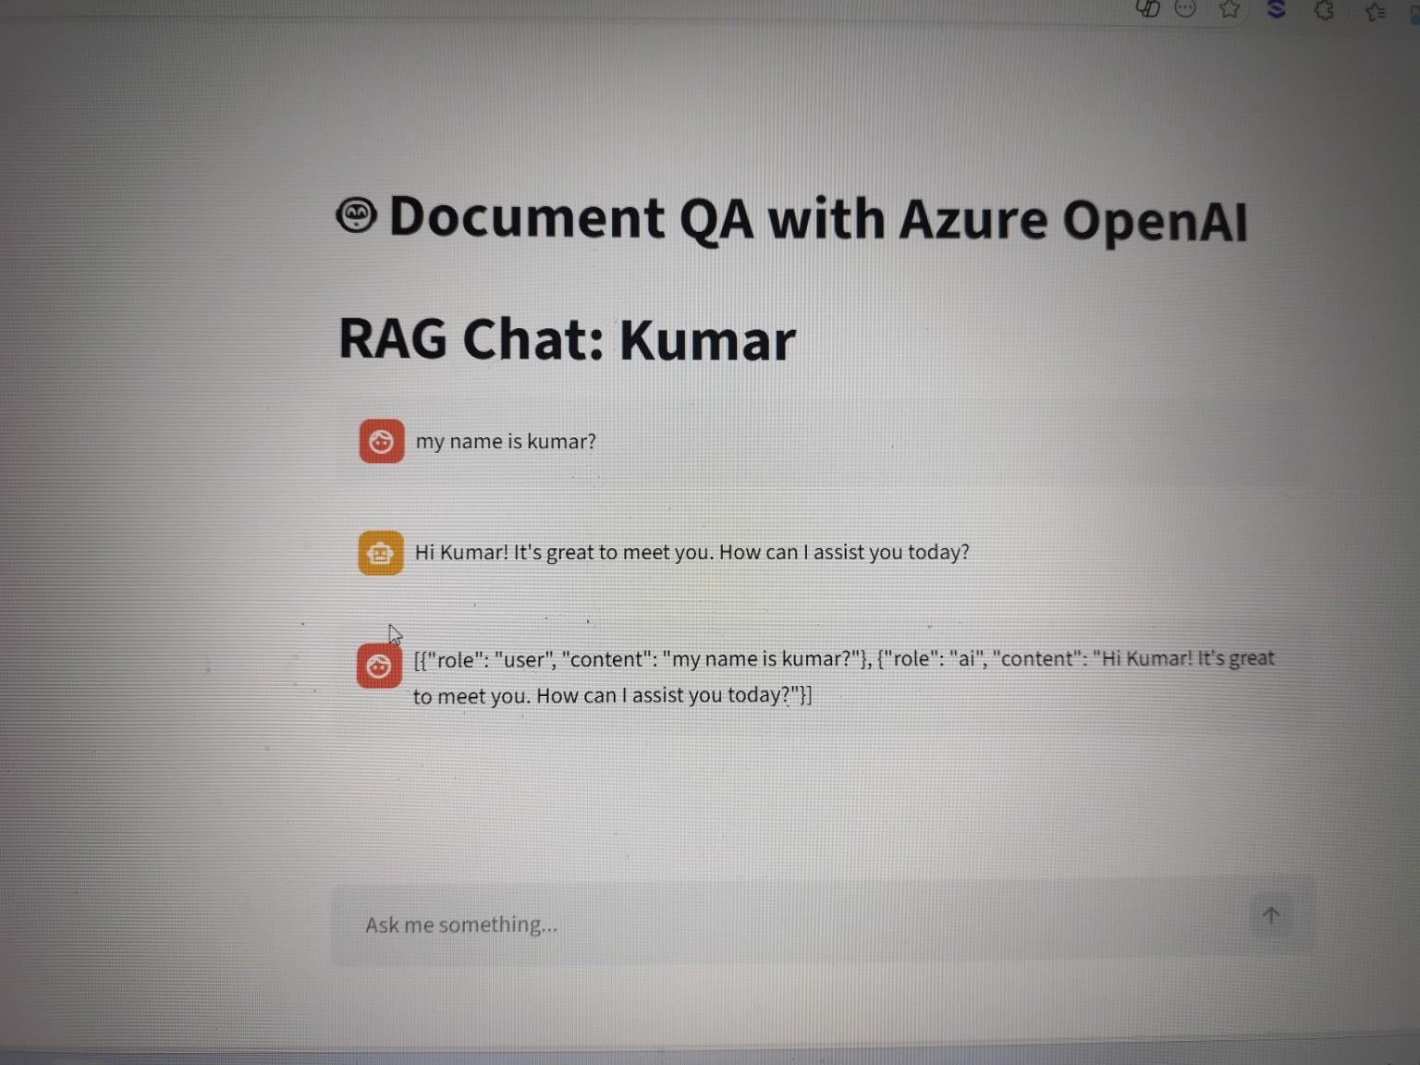
This isn't exactly a "crash" error, but a Data Formatting error. my bot is displaying raw code (JSON) in the chat window instead of a clean message.
🔍 Why is this happening?
This happens because you are accidentally displaying your entire database record as a single message.
In my code, ihave a loop that displays messages. When I load history from ChromaDB, iare fetching a string that looks like [{"role": "user", "content": "..."}]. If I don't "unpack" or parse that JSON string properly, Streamlit treats the whole block of code as one big text message.
🛠️ How to solve it
I need to find the part of my code where i load messages from the database (likely after a login or when clicking a sidebar button) and ensure you are using json.loads() and then looping through the individual messages.
The Fix
Check your loop where you display messages. It should look like this:
Python
# 1. When you get the document from ChromaDB, it is a STRING
raw_data = user_sessions["documents"][i]
# 2. You MUST parse it into a Python List
messages_list = json.loads(raw_data)

# 3. Then you display them one by one
for msg in messages_list:
with st.chat_message(msg["role"]):
st.markdown(msg["content"])

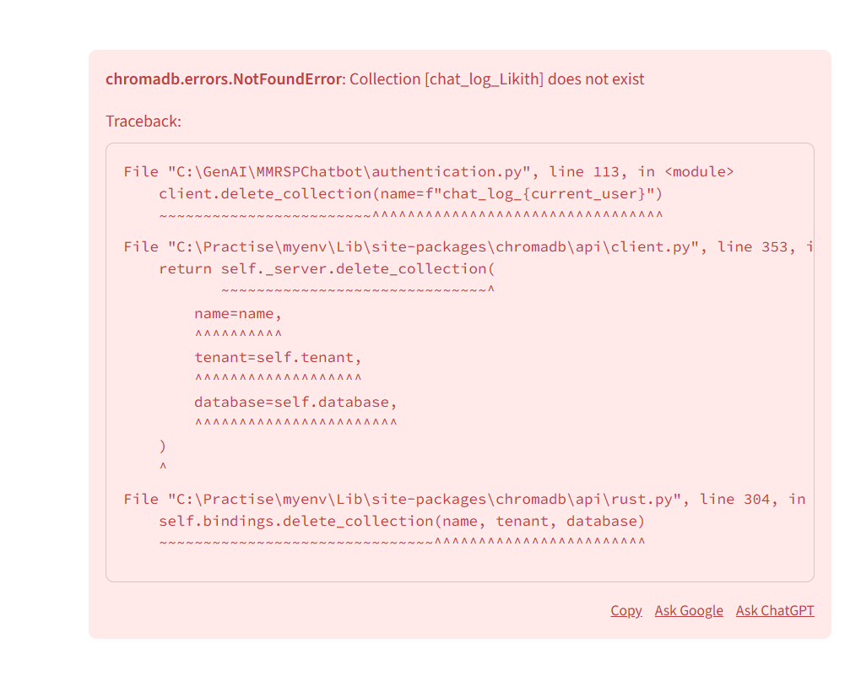
This is a chromadb.errors.NotFoundError.
It is happening because your code is trying to delete a collection that either was never created or has already been deleted.
🔍 Why it is coming
In your "Clear Chat History" button logic, you have this line: client.delete_collection(name=f"chat_log_{current_user}")
ChromaDB is very strict. If you tell it to delete chat_log_Likith but that specific folder/collection doesn't exist in the database yet, it crashes the whole app instead of just doing nothing. This usually happens if:
- A new user clicks "Clear History" before they have ever sent a message.
- The user clicks "Clear History" twice in a row.
🛠️ How to solve it
You need to wrap the delete command in a try-except block. This tells Python: "Try to delete this, but if it's not there, don't worry about it—just keep going."
Find Line 113 in your code and change it to this:
Python
if st.button("Clear Chat History"):
# Use try-except to catch the "NotFound" error
try:
client.delete_collection(name=f"chat_log_{current_user}")
st.success("History deleted from database!")
except Exception:
# If the collection doesn't exist, we don't need to do anything
st.warning("No history found to delete.")

# Clear the temporary UI state
st.session_state.messages = []
st.session_state.chat_history = []
st.rerun()
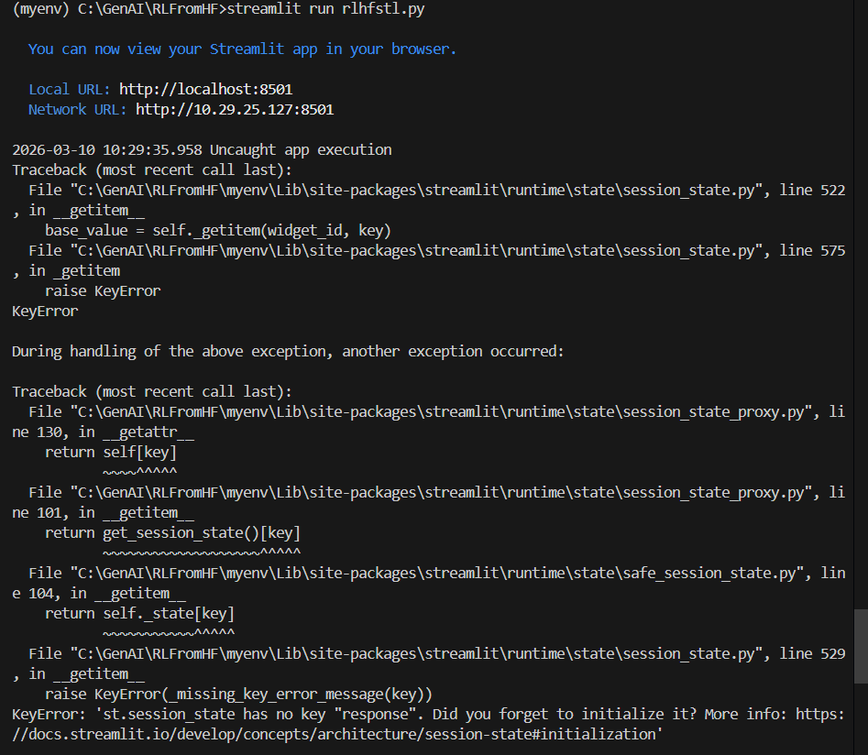

This is a KeyError: 'st.session_state has no key "response"'.
In simple terms, you are trying to read a variable named response from Streamlit's memory, but you haven't created it yet.

🔍 Why is this happening?
Streamlit runs your script from top to bottom every time you interact with the app. If your code tries to display or use st.session_state.response before the bot has actually generated an answer, the app crashes because that "key" doesn't exist in memory yet.
This usually happens when you try to display the bot's answer at the top of the script, but the logic that creates the answer is at the bottom.

🛠️ How to solve it
You must initialize the variable at the very beginning of your code (usually right after your imports) so that Streamlit knows it exists, even if it's empty.
The Fix
Add this block near the top of your rlhfstl.py file:
Python
# Check if "response" exists in memory; if not, create it as an empty string
if "response" not in st.session_state:
st.session_state["response"] = ""

